TSUNAMI EVACUATION SIMULATION AND THE EFFECT OF POPULATION DISTRIBUTION: A CASE STUDY OF PATONG, PHUKET, THAILAND
Nattapon Trumikaborworn^{1,*}, Panon Latcharote², and Pennung Warnitchai¹
¹ Asian Institute of Technology, Pathum Thani, Thailand, ² Mahidol University, Nakhon Pathom, Thailand
*Corresponding author: st120230@ait.asia

1. INTRODUCTION
In southern Thailand, Phuket was one of six provinces heavily affected by the 2004 Indian Ocean Tsunami. Patong is one of the most populated beaches in Phuket province. There are not only outdoor activities on the beach, but people can also enjoy several indoor activities, such as shopping, eating, massaging, etc., across the area. Therefore, population distribution can be implied by these activities related to the building occupancy classes, such as hotels, restaurants, shops, etc.
Generally, tsunami evacuation simulation begins with a model of the departure locations, also known as population distribution. For example, individuals initially depart from each building uniformly distributed or based on the building occupancy classes (BDOC), such as residential, hotel, commercial, etc. The number of occupants for each building class can be assumed based on expert judgment [1] or the field survey [2]
2. METHODOLOGY
In this study, we focus on the effect of population distribution on tsunami evacuation using agent-based modeling and simulation. The population in Patong, Phuket province is estimated based on the unit area of each building's occupancy class and the building’s floor area (m2).

Table 1. Overview of Building Distribution
Occupancy Class | %Building | Avg. Floor Area (m²)
Residential | 51.68% | 261
Hotel | 31.71% | 1,031
Commercial | 15.25% | 419
Others | 1.35% | 632
Grand Total | 100.00%

3. RESULTS
Table 2 shows that the population in commercial buildings based on the Uniform model is significantly less than in the BDOC model. Figure 2. shows that the BDOC model causes faster evacuation than the Uniform model, which may be caused by the high population being closer to safe places, such as tall buildings.

4. CONCLUSIONS
Population distribution significantly affected the tsunami evacuation and should be taken into consideration.

Table 2. Models of Population Distribution
Occupancy Class | %Pop. Dist. by Uniform Model | %Pop. Dist. by BDOC Model
Residential | 36.06% | 28.62%
Hotel | 44.16% | 37.66%
Commercial | 17.63% | 30.06%
Others | 2.15% | 3.65%

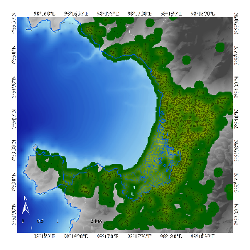  a) Uniform | 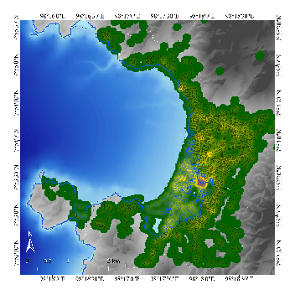  b) BDOC
Figure 1. Map of Population Distribution

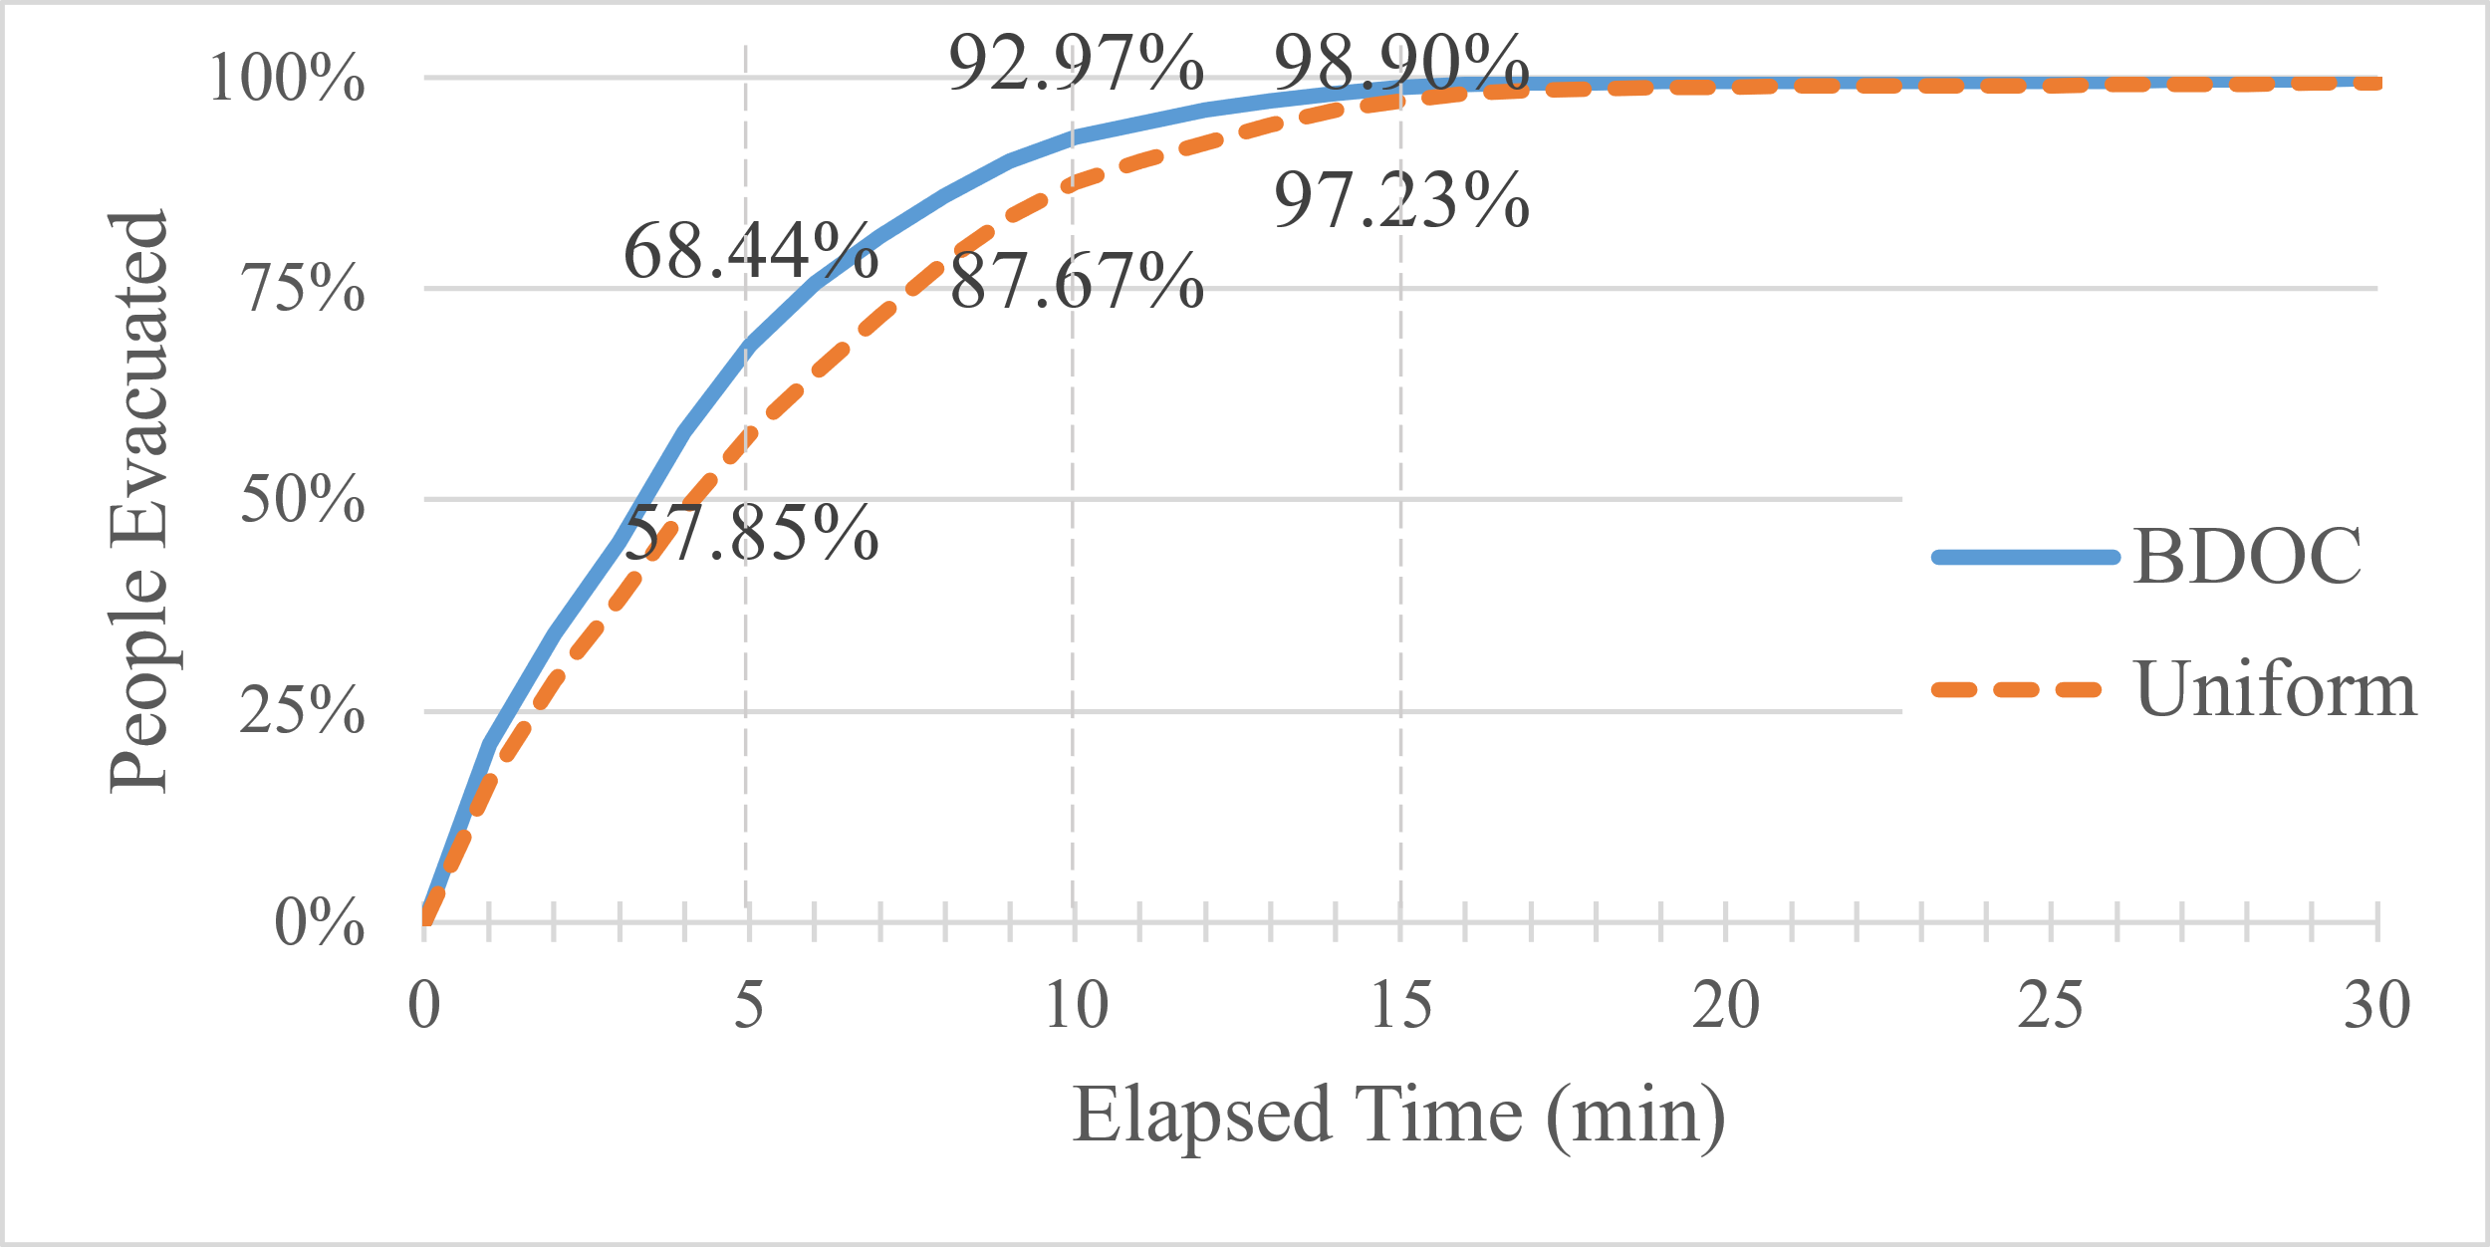
Figure 2. Effect of Population Distribution to the Results

5. REFERENCE
[1] T. Takabatake, I. Nistor, and P. St-Germain, “Tsunami evacuation simulation for the District of Tofino, Vancouver Island, Canada,” International Journal of Disaster Risk Reduction, vol. 48, Sep. 2020
[2] Y. Goto, M. Affan, Agussabti, Y. Nurdin, D. K. Yuliana, and Ardiansyah, “Tsunami evacuation simulation for disaster education and city planning,” Journal of Disaster Research, vol. 7, no. 1, pp. 92–101, 2012
6. AUTHOR BIOGRAPHIES
Nattapon Trumikaborworn currently works at the Disaster Preparedness, Mitigation and Management Program (DPMM), Asian Institute of Technology. Nattapon does research in An Agent-based Simulation of Tsunami Evacuation for disaster management.

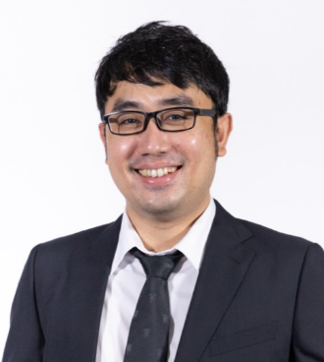
Panon Latcharote obtained D.Eng. in Infrastructure Systems Engineering from Kochi University of Technology, Japan. He is currently an assistant professor at Department of Civil and Environmental Engineering, Faculty of Engineering, Mahidol University. His research interests include physics-based computational and simulation engineering, nonlinear structural response analysis, multi-hazard risk assessment, statistical modeling and uncertainty quantification, and geographic Information System (GIS).

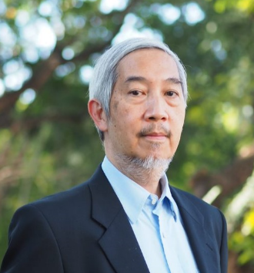
Pennung Warnitchai has D. Eng. in Civil Engineering from University of Tokyo, Japan and is currently the Professor in Structural Engineering Field of Study, School of Engineering and Technology, Asian Institute of Technology (AIT), Thailand. Prof. Warnitchai is also actively involved with the Disaster Preparedness, Mitigation, and Management Field of Study at AIT. Besides, Prof. Warnitchai association with AIT, he has been part of various significant elective and appointed offices both in Thailand as well as in the region. Some of Prof. Warnitchai current professional affiliations include: Scientific Board Member, The Global Earthquake Model; Member, National Earthquake Committee of Thailand; Chair, Chapter on the Effects of Earthquakes and Wind Loads, Engineering Institute of Thailand under H.M. the King’s Patronage; Member, Civil Engineering Chapter, Engineering Institute of Thailand under H.M. the King’s Patronage.

